AI – All Paper Answers
Define mean median mode. Explain a scenario the Median would be a more reliable measure of the central tendency than the Mean.

Mean (Average):
The mean is calculated by adding all values in a dataset and dividing by the total number of values. It uses every data point, so it gives an overall average. However, it is highly affected by extreme values (outliers).

Median:
The median is the middle value after arranging the data in order.
- If the number of observations is odd → middle value
- If even → average of two middle values
The median is not affected by very large or very small values, so it is more stable.

Mode:
The mode is the value that appears most frequently in a dataset. It is useful for identifying the most common observation.

Why Median Can Be More Reliable than Mean
The median is more reliable when:
- The data is skewed (not symmetric)
- There are outliers (extreme values)

Detailed Scenario (Income Example)
Consider incomes (₹):
20,000, 25,000, 28,000, 30,000, 35,000, 5,00,000
- Mean = Total / 6 = very high (affected by ₹5,00,000)
- Median = (28,000 + 30,000) / 2 = ₹29,000
The mean suggests people earn much more than they actually do.
The median shows the true central tendency of most individuals.

The median is preferred over the mean when data contains outliers or is skewed because it gives a more accurate and realistic central value.

Compare and contrast Conditional Statement (if - else) and loops(for/while) in Python. Provide a brief code snippet demonstrating how to use loop to literate through the list

Conditional Statements (if-else)
- Used for decision-making
- Executes a block of code based on a condition (True/False)
- Runs once per condition check
- Helps control program flow
Example use: Checking whether a number is even or odd

Loops (for, while)
- Used for iteration (repeating tasks)
- Executes a block of code multiple times
- Continues until a condition becomes false (while) or until all items are processed (for)
- Useful for processing collections like lists, tuples, etc.
Example use: Printing all elements in a list

Feature | if-else | Loops (for/while)
Purpose | Decision making | Repetition
Execution | Runs once | Runs multiple times
Condition | Checks condition | Repeats based on condition/sequence
Use Case | Branching logic | Iterating over data

Code
# List of items
numbers = [10, 20, 30, 40, 50]

# Using a for loop to iterate
for num in numbers:
print(num)

Explanation:
- The for loop takes each element from the list one by one
- num stores the current element
- The loop runs until all elements are printed

Use if-else when you need to make decisions
Use loops when you need to repeat actions or process multiple elements

Explain the difference between a Python List and a NumPy Array . In what scenario would you prefer one over the other for ML tasks?

Python List:
- A built-in data structure in Python
- Can store different data types (heterogeneous)
- Slower for numerical computations
- Does not support vectorized operations (requires loops)
- More flexible and easy to use

NumPy Array (from NumPy):
- A specialized data structure for numerical computing
- Stores same data type elements (homogeneous)
- Much faster and memory-efficient
- Supports vectorized operations (no need for explicit loops)
- Provides advanced mathematical and linear algebra functions

Feature | Python List | NumPy Array
Data Type | Heterogeneous | Homogeneous
Speed | Slower | Faster
Memory Usage | Higher | Lower
Operations | Requires loops | Vectorized operations
Use Case | General purpose | Numerical/Scientific computing

When to Prefer Each (ML Context)
Use Python Lists when:
- Working with small datasets
- Data contains mixed types (e.g., text + numbers)
- Simplicity and flexibility are more important than speed

Use NumPy Arrays when (Preferred for ML):
- Handling large datasets
- Performing mathematical computations (e.g., matrix operations)
- Building ML models where performance is critical
- Working with libraries like TensorFlow or scikit-learn

For machine learning tasks, NumPy arrays are preferred because they provide high performance, efficient memory usage, and fast numerical operations, which are essential for training models and processing large datasets. Python lists are mainly used for basic or small-scale tasks.

Difference between supervised and unsupervised learning, Provide two real applications for each.

Supervised Learning
Supervised learning is a type of machine learning in which the model is trained on labeled data, meaning each input is paired with a correct output. The algorithm learns the relationship (mapping function) between input and output and uses it to make predictions on new data.
Key characteristics:
- Uses labeled dataset
- Focuses on prediction
- Two main types:
  - Classification (e.g., spam vs not spam)
  - Regression (e.g., predicting prices)
- Easier to evaluate accuracy since correct answers are known
Examples of algorithms: Linear Regression, Decision Trees, Support Vector Machines

Unsupervised Learning
Unsupervised learning involves training a model on unlabeled data, where no predefined output is given. The model tries to identify patterns, structures, or relationships within the data.
Key characteristics:
- Uses unlabeled dataset
- Focuses on pattern discovery
- Main types:
  - Clustering (grouping similar data points)
  - Association (finding relationships between variables)
- Harder to evaluate because there is no ground truth
Examples of algorithms: K-Means Clustering, Hierarchical Clustering, Apriori Algorithm

Real-World Applications
Supervised Learning
- Email Spam Detection
  - Emails are labeled as spam or not spam, and the model learns to classify new emails.
- Medical Diagnosis
  - Predicts diseases based on patient data (symptoms, reports).

Unsupervised Learning
- Customer Segmentation
  - Groups customers based on purchasing behavior for marketing strategies.
- Market Basket Analysis
  - Identifies items frequently bought together (e.g., in supermarkets).

Supervised learning is used when labeled data is available and prediction is required, while unsupervised learning is used to explore data and uncover hidden patterns. Both are essential in machine learning and are often used together in real-world applications.

Explain the difference between correlation and regression. Does a high correlation between two-variable imply that one cause the other? Justify the answers

Correlation:
Correlation measures the strength and direction of the relationship between two variables. It is usually expressed by a coefficient $r$ranging from -1 to +1.
- $r=+1$: perfect positive relationship
- $r=-1$: perfect negative relationship
- $r=0$: no relationship
It does not distinguish between dependent and independent variables.

Regression:
Regression is a statistical method used to model the relationship between variables and predict one variable based on another. It establishes a functional relationship between:
- Independent variable (X)
- Dependent variable (Y)
For example, linear regression fits a line:
$$Y=a+bX$$
Does High Correlation Imply Causation?
No, high correlation does NOT imply causation.
Just because two variables are strongly related does not mean one causes the other.

Justification with Example
- Example: Ice cream sales and drowning incidents
  - They may show high positive correlation
  - But ice cream does not cause drowning
✔ The real reason is a third variable (confounding factor) → hot weather increases both.

Conclusion
- Correlation only indicates a relationship, not cause-effect
- Regression helps model and predict relationships
- A high correlation does not prove causation, as relationships may be influenced by hidden variables or coincidence

Explain the training, testing and validation sets. Why is it considered bad practices to evaluate a model's final performance using the training set ?

- Training Set (Learning Phase):
The training set is used to train the model, where it learns patterns, relationships, and parameters (weights) from the data.
- Size of Training Data:
It usually forms the largest portion (60–80%) of the dataset to ensure the model learns effectively.
- Validation Set (Tuning Phase):
The validation set is used to fine-tune hyperparameters such as learning rate, number of epochs, and model complexity.
- Model Selection:
It helps in comparing different models and selecting the best-performing model during training.
- Overfitting Detection:
By evaluating performance on validation data, we can detect overfitting (high training accuracy but low validation accuracy).
- Testing Set (Final Evaluation):
The testing set is used to assess the final performance of the trained model after all training and tuning is complete.
- Unseen Data Concept:
The testing set contains completely new and unseen data, ensuring an unbiased evaluation of the model.
- Why Not Use Training Set for Evaluation (Overfitting):
The model may memorize training data, leading to very high accuracy but poor real-world performance.
- Biased and Misleading Results:
Evaluating on the training set gives over-optimistic results, which do not reflect actual model capability.
- Lack of Generalization:
It fails to measure how well the model performs on new/unseen data, which is the main goal of machine learning.

Conclusion
Proper separation of training, validation, and testing sets ensures accurate, fair, and reliable model evaluation, while using the training set for final performance leads to incorrect and misleading conclusions.

Describe Overfitting and Underfitting using the concept of Bias and the Variance. how can Hyperparamter be used to mitigate overfitting ?

1. Underfitting (High Bias, Low Variance)
Underfitting occurs when a model is too simple to capture the underlying patterns in the data.
- The model makes strong assumptions about the data → leads to high bias.
- It cannot learn important relationships between input and output.
- As a result, it performs poorly on both training and testing data.
Example:
Fitting a straight line (linear model) to data that actually follows a complex curve.

2. Overfitting (Low Bias, High Variance)
Overfitting occurs when a model is too complex and learns not only the patterns but also the noise in the training data.
- The model has low bias (fits training data very well).
- But it has high variance, meaning it is very sensitive to small changes in data.
- It performs very well on training data but poorly on unseen (test) data.
Example:
A deep decision tree or neural network that memorizes training data instead of generalizing.

3. Bias–Variance Concept
- Bias: Error due to overly simple assumptions in the model
→ High bias leads to underfitting
- Variance: Error due to model sensitivity to training data
→ High variance leads to overfitting
A good model should achieve a balance between bias and variance, known as the bias–variance tradeoff.

4. Using Hyperparameters to Mitigate Overfitting
Hyperparameters are settings that control the learning process and model complexity. Proper tuning can reduce overfitting:
- Regularization (L1/L2):
Adds a penalty for large weights, reducing model complexity and preventing overfitting.
- Limiting Model Complexity:
Reduce tree depth, number of features, or number of layers/neurons in neural networks.
- Early Stopping:
Stop training when validation error starts increasing, preventing the model from memorizing noise.
- Dropout (Neural Networks):
Randomly deactivate some neurons during training to improve generalization.
- Increase Training Data / Data Augmentation:
More diverse data reduces variance and improves model robustness.

5. Conclusion
- Underfitting: High bias, low variance → model too simple
- Overfitting: Low bias, high variance → model too complex
- By tuning hyperparameters, we can control complexity and achieve a balanced model that generalizes well to new data.

Sums :
x (Projects) | y (Salary in हजार) | xy | X²
2 | 60 | 120 | 4
4 | 70 | 280 | 16
6 | 80 | 480 | 36
8 | 90 | 720 | 64
10 | 100 | 1000 | 100
12 | 110 | 1320 | 144
Total = 42 | Total = 510 | Total = 364 | Total = 3920

Find Slope (m)
Using formula:
$$m=\frac{n∑xy-∑x∑y}{n∑x^{2}-(∑x)^{2}}$$
$$m=\frac{23520-21420}{2184-1764}$$
$$m=\frac{2100}{420}=5$$

Intercept (c)
$$c=\frac{510-(5×42)}{6}=\frac{300}{6}=50$$
Slope (m) = 5
Intercept (c) = 50

A high-security airport terminal implemented a new Al-driven baggage scanner to detect prohibited items. Out of 1,000 suitcases screened, 80 bags actually contained prohibited items, while 920 bags were perfectly clear. The scanner successfully flagged 72 of the prohibited bags, but it also incorrectly
triggered an alarm for 46 clear bags, causing them to be pulled aside for manual inspection. Construct the confusion matrix, calculate the Recall, and explain what the False Negative (FN) value represents in the context of airport safety

Given Data
- Total bags = 1000
- Bags with prohibited items = 80
- Clear bags = 920
- Correctly detected prohibited bags = 72 → TP (True Positive)
- Incorrectly flagged clear bags = 46 → FP (False Positive)

Step 1: Calculate Remaining Values
- False Negative (FN) = 80 − 72 = 8
- True Negative (TN) = 920 − 46 = 874

 | Predicted Positive | Predicted Negative
Actual Positive | TP = 72 | FN = 8
Actual Negative | FP = 46 | TN = 874

Step 3: Calculate Recall
$$\text{Recall}=\frac{TP}{TP+FN}$$
$$\text{Recall}=\frac{72}{72+8}=\frac{72}{80}=0.9$$
$$\text{Recall}=90\%$$
Importance in Airport Safety
- False Negatives are very critical in this context.
- They represent security failures, where threats go undetected.
- Even a small FN rate can lead to serious risks to passengers and airport security.

Conclusion
- Confusion Matrix constructed correctly
- Recall = 90%
- FN represents missed threats, making it the most dangerous error in security systems

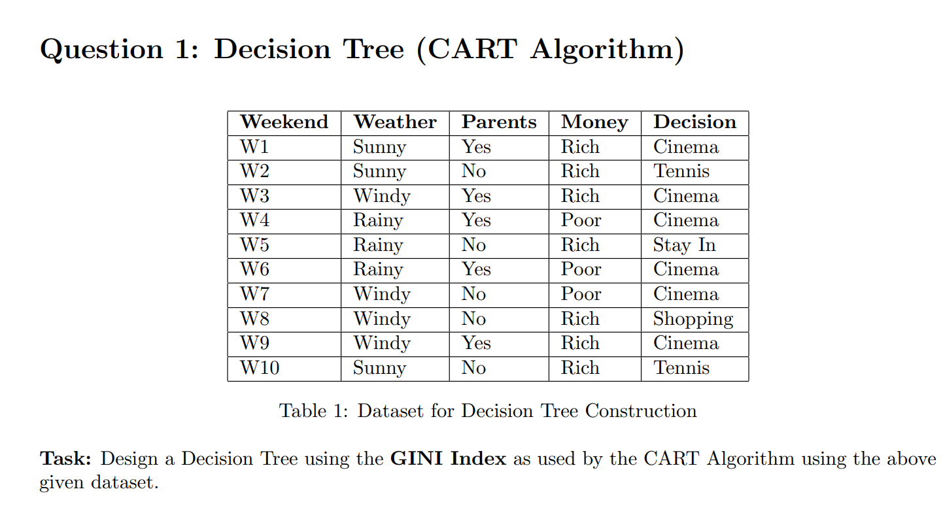

Step 1: Count Target Classes (Decision)
From dataset:
- Cinema = 6
- Tennis = 2
- Stay In = 1
- Shopping = 1
- Total = 10

Step 2: GINI of Dataset
$$GINI(D)=1-∑p_{i}^{2}$$
$$=1-\left({\left(\frac{6}{10}\right)}^{2} + {\left(\frac{2}{10}\right)}^{2} + {\left(\frac{1}{10}\right)}^{2} + {\left(\frac{1}{10}\right)}^{2}\right)$$
$$=1-(0.36+0.04+0.01+0.01)$$
$$=1-0.42=0.58$$

Step 3: GINI Split for Each Attribute
1. Weather
Sunny (3 records)
- Cinema = 1, Tennis = 2
$$GINI=1-\left({\frac{1}{3}}^{2} + {\frac{2}{3}}^{2}\right)=0.444$$
Windy (4 records)
- Cinema = 3, Shopping = 1
$$GINI=1-\left({\frac{3}{4}}^{2} + {\frac{1}{4}}^{2}\right)=0.375$$
Rainy (3 records)
- Cinema = 2, Stay In = 1
$$GINI=0.444$$
Weighted GINI (Weather)
$$=\frac{3}{10}(0.444)+\frac{4}{10}(0.375)+\frac{3}{10}(0.444)=0.416$$

2. Parents
Yes (5 records)
- All Cinema
$$GINI=0$$
No (5 records)
- Tennis = 2, Stay In = 1, Shopping = 1, Cinema = 1
$$GINI=1-(0.16+0.04+0.04+0.04)=0.72$$
Weighted GINI (Parents)
$$=\frac{5}{10}(0)+\frac{5}{10}(0.72)=0.36$$
3. Money
Rich (7 records)
- Cinema = 3, Tennis = 2, Stay In = 1, Shopping = 1
$$GINI=1-(0.184+0.081+0.02+0.02)=0.695$$
Poor (3 records)
- All Cinema
$$GINI=0$$
Weighted GINI (Money)
$$=\frac{7}{10}(0.695)+\frac{3}{10}(0)=0.486$$
Parents
/ \
Yes No
| / | \
Cinema Sunny Rainy Windy
| | |
Tennis Stay In Money
/ \
Poor Richp
| |
Cinema Shopping

